2025 Employee Benefits Guide

Class 1 & 3 – All Employees

# PICK THE BEST BENEFITS FOR YOU AND YOUR FAMILY.

At FLASH Family of Companies, we believe that our employees are the most valuable asset, and we are committed to providing you with a benefits package that reflects our appreciation for your hard work and dedication. This booklet gives you an overview of some of the benefits FLASH offers; you will find detailed information about your health insurance options, retirement savings plan, paid time off and many other important benefits.

FLASH takes your healthcare and benefits plan seriously. That is why we take time each year to review your benefits and options. We strive to provide you quality benefits while balancing the cost for you. Please review this information so you can select the plans that best meet your needs and the needs of your family. We understand that navigating the world of employee benefits can sometimes be overwhelming, so we have made every effort to ensure that this booklet is clear, concise and easy to understand. Whether you are looking for information about how to enroll in a health insurance plan or wanting to learn more about our employee assistance program, you will find everything you need right here.

Your benefits are an important part of your total compensation package, and we want to make sure that you are taking full advantage of everything that is available to you. If you have any questions about your benefits or need assistance, please do not hesitate to reach out to our Human Resources department; we are here to help!

Because everyone’s needs are different, our benefits package is flexible and can be customized to suit your individual situation. No matter which plans you choose, the best way to save money on health care is to stay well by leading a healthy lifestyle – eating right, exercising, utilizing preventive care, and developing health habits.

Open enrollment is a short period each year when you can make changes to your benefits. This guide will outline all of the different benefits FLASH offers, so you can identify which offerings are best for you and your family.

Elections you make during open enrollment will become effective on January 1, 2025. If you have questions about any of the benefits mentioned in this guide, please don’t hesitate to reach out to HR.

Thank you for being a valuable member of the FLASH Family of Companies team. We are proud to have you with us and look forward to continuing to support you in your professional journey.

Exciting News for 2025!



Introducing your New Discounts & Rewards marketplace. It’s easy to use and features thousands of deals on the brands you know and love. You’ll find discounts for sporting events, theme parks, travel, hotels, restaurants, cars and your favorite local establishments. Earn Cashback Rewards from 2% - 20% on everyday purchases and big-ticket items. There is no limit to the savings you’ll find, so feel free to Shop, Save and Earn as much as you like. You can even shop for Home and Auto insurance with 20 national carriers!

TabLE OF CONTENTS

What’s New 2

Enrollment Basics 3

Eligibility 4

How to Enroll 5

Health Insurance 6

Health Savings Accounts 7

Prescription Coverage 8

Dental Insurance 9

Vision Insurance 9

Life and AD&D Insurance 10

Disability Income Benefits 11

Hospital Indemnity 12

Accident Insurance and Schedule of Benefits 13-14

Critical Illness 15

$50 Wellness Benefit 16

Employee Assistance Program 17

Gym Membership 18

401(k) 19

Time Away 20

Contact Information 12

Note: This is a summary of benefits and not in any way a guarantee of coverage. This summary provides a general description of your benefits. It does NOT list all benefits. The plan contains limitations and restrictions that could reduce the benefits payable under the plan. The Summary Plan Description will take precedence over all other documents.

ENROLLMENT & BENEFIT BASICS

**BE PREPARED**  
Before your benefit coordinator meeting, be sure to read this benefit guide, review your options and write down any questions you may have. Please note the following:

* Social Security numbers are required for newly enrolled dependents
* You will be asked to provide beneficiary names, birth dates, addresses and phone numbers

**Initial Enrollment Period Upon Meeting Eligibility**  
If you are an employee working 30 or more hours per week, you are eligible for benefits starting the 91st day of employment. You must enroll during the enrollment period: within 30 days of your eligibility date. If you do not enroll during this timeframe, it will be deemed a “wavier of participation.”

**Results of Waiving Coverage & Eligibility Periods**  
If coverage is waived during your initial enrollment period, future entrance into any benefits plan will only be allowed if you experience a Qualified Life Event (i.e. Marriage, Divorce, Birth of Child, Adoption, Death of a dependent, Loss of other coverage, Dependent ineligibility) or Annual Open Enrollment Periods.

**Making Changes During the Year**A Qualified Life Event is a change in your personal life that may impact your eligibility, or your dependent’s eligibility, for benefits. Examples of some Qualifying Events include:

* Change of legal marital status (e.g. marriage, divorce, death of spouse)
* Change in number of dependents (e.g. birth, adoptions, court order, death of dependent, eligibility due to age
* Change in employment or job status of you or your spouse.

If such a change occurs, you must make the changes to your benefits within 30 days of the Qualifying Life Event date. Documentation will be required to verify the change in status. If you fail to request a change within 30 days of the Qualifying Event, you may have to wait until the next Annual Open Enrollment period to make your change; this includes the enrollment of a newborn child.

**No – Cost and Affordable Care Act Information**FLASH offers one of our three health insurance plans to you with NO premium for single coverage. This means you have coverage with no required contribution from your paycheck. While there are usage fees such as a deductible, you are able to acquire coverage without upfront costs. Our goal is to make sure health coverage is accessible to all of our eligible employees.

Offering coverage at no premium doesn’t mean that you need to enroll in our coverage. You may have an alternative coverage option (such as a spouse’s plan) which you may find to be more desirable. We know that every household makes the best decision for their unique needs.

We do want you to understand one component of our offer. Since one of our offers of health insurance coverage is offered at no premium for single coverage, its is considered to be “affordable” under the Affordable Care Act (ACA) requirements. Due to the affordability of our plan, you may not qualify for subsidies if you were to seek coverage via the Marketplace (coverage acquired via Healthcare.gov). This means that even if you declined our coverage offer, those subsidies may not be available to you.

We share this information not to direct you to enroll in a particular plan, but to help you better understand your options. We want you to make the best coverage decision for your unique situation.   
  
**WHO IS ELIGIBLE?**Employees are eligible to enroll in the FLASH Family benefits program if you are a regular full-time employee who is actively working a minimum of 30 hours per week. Your benefits are effective starting the 91st day of employment. You must enroll during the enrollment period: within 30 days of your eligibility date and/or annual open enrollment. If you do not enroll during the required time frames, it will be deemed a “wavier of participation.”   
When you enroll, you may also elect coverage for your dependents.  
Eligible dependents generally include your legal spouse and children, up to age 26. Children may include natural, adopted, stepchildren, and children obtained through court-appointed legal guardianship.

* Dependent child(ren) are covered through the end of month they turn age 26, regardless of marital status.
* Dependent child(ren) are also eligible for benefit if the Employee is required to provide benefits through a divorce decree, court order or Qualified Medical Child Support Order (QMCSO)

WORKING SPOUSE PROVISION

If your spouse is eligible for group medical or health insurance through their employer, then they will not be eligible to obtain coverage under the FLASH Family group medical plan. You must attest to your spouse’s eligibility for participation in the FLASH Family medical plan.

How to enroll

Are you ready to enroll? The first step is to review your current benefits. Did you move recently or get married? Verify all of your personal information and make any necessary changes.

Once all your information is up to date, it’s time to make your benefit elections. The decisions you make during open enrollment can have a significant impact on your life and finances, so it is important to weigh your options carefully.

When to enroll

Open enrollment begins on Friday, November 1, 2024 and runs through Friday, November 8, 2024. The benefits you choose during open enrollment will become effective on January 1, 2025.

How to make changes

Unless you experience a life-changing qualifying event, you cannot make changes to your benefits until the next open enrollment period. Qualifying events include things like:

Marriage, divorce or legal separation

Birth or adoption of a child

Change in child’s dependent status

Death of a spouse, child or other qualified dependent

Change in residence

Change in employment status or a change in coverage under another employer-sponsored plan

ENROLLMENT INstructions

When to enroll

Open enrollment begins on Friday, November 1, 2024 and runs through Friday, November 8, 2024.   
The benefits you choose during open enrollment will become effective on January 1, 2025.

Please log into the Employee Navigator portal and complete your open enrollment within the timeframe above.

If you have questions about your benefits, you may schedule time to speak with a benefit counselor

Access appointments

Scheduling link: [http://tiny.cc/flashoe](https://nam02.safelinks.protection.outlook.com/?url=http%3A%2F%2Ftiny.cc%2Fflashoe&data=05%7C02%7Cshannon.l.smith%40aon.com%7C023319e96caf413ad29e08dce2f9b8b3%7C94cfddbc0627494aad7a29aea3aea832%7C0%7C0%7C638634810953511526%7CUnknown%7CTWFpbGZsb3d8eyJWIjoiMC4wLjAwMDAiLCJQIjoiV2luMzIiLCJBTiI6Ik1haWwiLCJXVCI6Mn0%3D%7C0%7C%7C%7C&sdata=ZghxuGyf8bZFpyPZ%2FStgc9RXC3rjxP5mVErE%2FmvC2h0%3D&reserved=0)

Scheduling QR Code:

Health Insurance Administered by UMR

We recognize that medical benefits are important to our employees, so FLASH’s medical plans provide comprehensive coverage for you and your family. FLASH Family offers 3 medical plans, listed below, through UMR. With these plans you can visit any provider in the United States, although your out-of-pocket costs will generally be lower if you see a provider who participates in the UHC/Choice Plus network.   
To locate a participating provider, log on to **www.uhc.com**.   
Choose **Find a Doctor**. Select **Physician, Hospital or health care facility** as the type of care you are searching for.

Select **Medical Directory** . Select **All UnitedHealthcare Plans**

Select **Choice Plus** as the plan/network. Search by **Provider**, **Service** or **Condition**

|  |  |  |  |  |  |  |
| --- | --- | --- | --- | --- | --- | --- |
|  | **Plan 1: PPO Plan** | | **Plan 2: HDHP with HSA** | | **Plan 3: HDHP with HSA** | |
| **Services \*** | **In Network** | **Out of Network** | **In Network** | **Out of Network** | **In Network** | **Out of Network** |
| Calendar Year Deductible | $1,500 Person | $3,000 Person | $3,300 Person | $6,600 Person | $6,000 Person | $12,000 Person |
| $3,000 Family | $6,000 Family | $6,600 Family | $13,200 Family | $12,000 Family | $24,000 Family |
| Out of Pocket Maximum | $1,800 Person | $4,200 Person | $3,600 Person | $8,400 Person | $7,000 Person | $14,000 Person |
| $3,600 Family | $8,400 Family | $7,200 Family | $16,800 Family | $14,000 Family | $28,000 Family |
| Primary Care Visit | $25 per visit | 30% coins | 10% coins | 30% coins | 0% coins | 30% coins |
| Specialist Visit | 10% coins | 30% coins | 10% coins | 30% coins | 0% coins | 30% coins |
| Preventive Care | No Charge | 30% Coins | No Charge | 30% Coins | No Charge | 30% Coins |
| Diagnostic Lab & X-ray Including Advance | 10% coins | 30% coins | 10% coins | 30% coins | 0% coins | 30% coins |
| Durable Medical Equip & Prosthetic Devices | 10% coins | 30% coins | 10% coins | 30% coins | 0% coins | 30% coins |
| Emergency Room | $250 copay, then deductible Deductible waived if admitted | | 10% coins after deductible  In-Network deductible applies to  Out of Network ER care | | No Charge after deductible  In-Network deductible applies to  Out of Network ER care | |
| Urgent Care | $25 per visit | | 10% coins | 30% coins | 0% coins | 30% coins |
| Hospital – Inpatient | 10% coins | 30% coins | 10% coins | 30% coins | 0% coins | 30% coins |
| Hospital – Outpatient | 10% coins | 30% coins | 10% coins | 30% coins | 0% coins | 30% coins |
| **Retail Prescription Drugs (30-day Supply) \*** | | | | | | |
| Generic | $10 copay | | 10% coinsurance | | No charge after deductible | |
| Brand Preferred | 20% coins; $20 minimum | | 10% coinsurance | | No charge after deductible | |
| Brand Non-preferred | 30% coins; $35 minimum | | 15% coinsurance | | No charge after deductible | |
| **Mail Order Prescription Drugs (90-day Supply) \*** | | | | | | |
| Generic | $10 copay | | 10% coinsurance | | No charge after deductible | |
| Brand Preferred | 20% coins; $40 minimum | | 10% coinsurance | | No charge after deductible | |
| Brand Non-preferred | 30% coins; $70 minimum | | 15% coinsurance | | No charge after deductible | |

**\***Any service listed with “coins” indicates coinsurance percentage after deductible has been satisfied

Medical Plan Costs

|  |  |  |  |
| --- | --- | --- | --- |
| **Per Semi-Monthly Pay Period** | **Plan 1: PPO Plan** | **Plan 2: HDHP with HSA** | **Plan 3: HDHP with HSA** |
| Employee Only | $135.50 | $99.50 | $0.00 |
| Employee + Spouse | $270.50 | $198.50 | $155.50 |
| Employee + Child(ren) | $243.50 | $179.50 | $140.50 |
| Employee + Family | $365.50 | $268.50 | $210.00 |

Health Savings Account (hsA) *Administered by EBC*

Health savings accounts (HSAs) are a great way to save money and budget for qualified medical expenses. HSAs are tax-advantaged savings accounts that accompany high deductible health plans (HDHPs). HDHPs offer lower monthly premiums in exchange for a higher deductible (the amount you pay before insurance kicks in). Those who enroll in one of the FLASH family HDHP (Plan 2 or 3) are eligible to contribute to an HSA. HSA funds can be used to pay for any qualified, out-of-pocket medical, dental or vision expense. This includes, but is not limited to out-of-pocket deductible, coinsurance and copayment expenses. TAX FREE!

WHAT ARE THE BENEFITS OF AN HSA?

There are many benefits of using an HSA, including the following:

It saves you money. HDHPs have lower monthly premiums, meaning less money is being taken out of your paycheck.

It is portable. The money in your HSA is carried over from year to year and is yours to keep, even if you leave the company.

It is a tax-saver—HSA contributions are made with pre-tax dollars. Since your taxable income is decreased by your contributions, you’ll pay less in taxes.

**The maximum amount** that you can contribute to an HSA in 2025 is $4,300 for individual coverage and $8,550 for family coverage. Additionally, if you are age 55 or older, you may make an additional “catch-up” contribution of $1,000.   
You may change your contribution amount at any time throughout the year as long as you don’t exceed the annual maximum.  
Can pay for eligible expenses of your legal spouse and tax dependents regardless of their insurance.  
Can be used for Medicare premiums as well as a qualified long-term care premiums.

How to deposit funds into an hsa account?

Flash Family must have your HSA account information on file. Employees simply establish a qualified HSA account with the bank of their choosing and send that information to payroll for direct deposit of your elected contribution amount per pay check.

**Cost saving options**

|  |  |  |  |
| --- | --- | --- | --- |
| **Care Type** | **Care Provider** | **Average Cost** | **Why Choose this?** |
| **Teladoc**  Teladochealth.com  Call 800-835-2362  Mobile app | Board certified Physicians | $54 | ■ Minor allergic reactions ■Cold, cough, sore throat ■ Minor headaches ■Eye or ear pain or irritation ■ Nausea or Diarrhea ■Burning with urination ■Sinus pain, fever |
| **Walk In** Doctors Visit | Family Practice Physicians | $154 | ■Mild asthma ■Minor Burns ■Back Pain ■Painful urination |
| **Urgent Care** Center | Family Practice & Emergency Care Physicians | $226 | ■Animal bites ■Stitches ■Sprains/Strains ■X-rays |
| **Emergency Room** | Emergency Care Physicians | $2,500 | ■Chest Pain ■Slurred speech ■Shortness of breath ■Weakness/numbness on one side ■Broken bones/dislocated joints |

medical prescription coverage Administered by Optum Rx

The OptumRx website and app are fast, easy, and secure ways to get information you need to make the most of your pharmacy benefit. Register for an online account and you can:

* Check drug prices
* Place a home delivery order
* Track home deliver status
* Sing up for automatic refills
* View claims and benefit information

To set up your online account:

* Go to OptumRx.com
* Select Register on the home page
* Enter the information from your UMR member ID card
* Create a username and password
* Complete your profile

Once you have an account created go to member.umr.com to log into your account once initial set up is complete

Pharmacy discount options

**CAUTION!**

When using any of these pharmacy discount programs, your claims will not go through your insurance benefit and will not be applied to your deductible or out of pocket limit. Feel free to use your HSA to help pay for your prescriptions.

**GoodRx**

GoodRx provides discounts for thousands of prescription

drugs at more than 70,000 local and mail-order pharmacies

in the USA.

**Walmart $4 Drug List**

The Walmart $4 Drug List includes low-cost generic medications.

It has no membership fees, does not require insurance, and is

routinely updated to reflect new medications, list additions and

removals.   
Visit Walmart.com/cp/4-prescriptions/1078664

**Amazon Pharmacy**

Amazon Pharmacy can fill most common prescriptions and offers

transparent pricing, simple refills and discrete delivery to your door.

The pharmacists are available for consultation 24/7.

Dental Insurance Administered by Guardian

You have a choice between two dental plans. The Low Plan is like the other dental offering, but Orthodontics are not covered. The High Plan includes Orthodontic coverage and increases the annual maximum to $2,000. To locate a participating dentist, log on to Guardiananytime.com.

**Diagnostic & Preventive**

Exams, Cleanings, X-rays

**Basic Services**

Fillings, Extractions  
Endodontics & Periodontics

General anesthesia

**Major Services**

Crowns, Prosthodontics

Implants

|  |  |  |  |  |
| --- | --- | --- | --- | --- |
|  | **Low Plan** | | **High Plan** | |
| **TYPE OF SERVICE** | **In Network** | **Out of Network** | **In Network** | **Out of Network** |
| Annual Deductible | $50 Individual / $150 Family | | $50 Individual / $150 Family | |
| Annual Maximum (per person) | $1,000 | | $2,000 | |
| **Diagnostic & Preventive** | 100% | | 100% | |
| **Basic Service** | 90% | 80% | 90% | 80% |
| **Major Services** | 60% | 50% | 60% | 50% |
| ***Orthodontia (child only under 19)*** | Not Covered | | 50% / $2,000 Lifetime Max | |

Dental Plan Costs

|  |  |  |
| --- | --- | --- |
| **Per Semi-Monthly Pay Period** | **Low Plan** | **High Plan** |
| Employee Only | $19.06 | $21.66 |
| Employee + Spouse | $38.24 | $44.38 |
| Employee + Child(ren) | $38.24 | $44.38 |
| Employee + Family | $52.95 | $65.03 |

Vision Insurance Administered by guardian

Your vision insurance network is VSP

|  |  |  |
| --- | --- | --- |
| **TYPE OF SERVICE** | **In Network** | **Out of Network** |
| Eye Exam Copay | $20 | $20 |
| Eye Exam | Covered 100% after copay | $39 max after copay |
| (covered once per calendar year) |
| Materials Copay | $20 | $20 |
| Lenses | $20 copay | $23-64 max after copay |
| (covered 1x per calendar year) |
| Frames | $135 retail allowance + 20% off balance | $46 max after $20 copay |
| (covered 1x every 2 calendar years) |
| Contact Lenses | $135 retail allowance | $100 max |
| (covered 1x every calendar year) |
| Laser Vision Correction Surgery | Up To 25% off the usual charge or  5% off promotional price | No Discounts |
| Vision Network: VSP | www.guardiananytime.com | |

Vision Plan Costs

|  |  |
| --- | --- |
| **Per Semi-Monthly Pay Period** |  |
| Employee Only | $4.32 |
| Employee + 1 Dependent | $6.55 |
| Employee + Family | $11.51 |

Group basic Life and AD&D Insurance Administered by guardian

Group Basic Life insurance can help provide for your loved ones if something where to happen to you. FLASH Family provides full-time employees with 1 x your annual salary to a maximum of $125,000 in group life and an equal amount of accidental death and dismemberment (AD&D) insurance.

FLASH Family pays for the full cost of this benefit—meaning you are not responsible for paying any monthly premiums. Contact HR if you would like to update your beneficiary information.

Voluntary Term Life and AD&D Insurance Administered by Guardian

Paid by You

### 

While FLASH Family offers basic life insurance, some employees may want to purchase additional coverage. Think about your personal circumstances. Are you the sole provider for your household? What other expenses do you expect in the future (for example, college tuition for your child)? Depending on your needs, you may want to consider buying supplemental coverage.

With voluntary life insurance, you are responsible for paying the full cost of coverage through biweekly payroll deductions.

This plan is portable should you leave FLASH employment and wish to continue coverage for yourself and your dependents until age 70.   
Age Reduction – Benefits reduce 35% at age 65, 60% at age 70, 75% at age 75 and 85% at age 80.

|  |  |
| --- | --- |
|  | **Benefit Coverage Amounts** |
| YOU | $10,000 - $250,000 (Increments of $10,000) |
| Your  Spouse | $10,000 - $250,000 (Increments of $5,000) Spouse benefit cannot exceed Employee benefit |
| Your  Child(ren) to age 26 | $5,000 or $10,000 Child benefit cannot exceed Employee benefit |

|  |  |  |
| --- | --- | --- |
| **Guaranteed Issue Coverage** | | |
| **New Hires** | **Annual Enrollment  (Employees Currently Enrolled)** | **Annual Enrollment  (NOT Currently Enrolled)** |
| Less than age 65: $100,000 65-69: $50,000 70+: $10,000 | Employees may increase up to an amount of $50,000, to the Guarantee Issue amount, without completing medical questions | All amounts are subject to  Medical Health Questions |
| Less than age 65: $25,000 65-69: $10,000 70+: $0 | All amounts are subject to  Medical Health Questions |
| All child coverage is  Guarantee Issue | All amounts are subject to  Medical Health Questions |

voluntary Disability Income Benefits Administered by guardian

Paid by You

FLASH Family provides full-time employees an option to purchase short- and long-term disability income benefits. Without disability coverage, you and your family may struggle to get by if you miss work due to an injury or illness.

In the event that you become disabled from a non-work-related injury or sickness, disability income benefits will provide a partial replacement of lost income. Please note, though, that you are not eligible to receive short-term disability benefits if you are receiving workers’ compensation benefits.

|  |  |  |
| --- | --- | --- |
|  | **Voluntary  Short-term Disability** | **Voluntary  Long-term Disability** |
| Benefits Begin | 15th day for injury 15th day for sickness | 90-day elimination period |
| Benefits Payable | 11 weeks as long as you remain disabled | Paid for up to your social security normal retirement age, as long as you remain disabled |
| Percentage of Income Replaced | 60% | 60% |
| Maximum Benefit | $800 per week | $8,000 per month |
| Other | Claims are subject to 3/12 pre-existing condition exclusion with 2-week limitation | Claims are subject to 6/24 pre-existing condition exclusion |
| Maternity | Covered as any other illness | N/A |

voluntary Disability Income Benefits Administered by guardian

Paid by You



**HOSPTIAL INDEMNTIY INSURANCE**

Planned or unplanned, a trip to the hospital can be scary. It can be even more frightening to know that your medical insurance probably won’t cover all your costs. Group Hospital Indemnity insurance can help cover unexpected out-of-pockets expenses such as copays, deductibles, and out-of-network charges, as well as everyday living expenses. It pays a benefit directly to you for hospital-related events, regardless of your treatment costs or other insurance coverage you might have.



|  |  |
| --- | --- |
| **Sample Out-of-Pocket Expenses** | |
| Medical plan deductible & coinsurance | $2,800 |
| Other non-medical expenses | $475 |
| **Total Expenses** | **$3,275** |
| **Benefits Paid to You** | |
| Hospital Admission | $500 |
| ICU Confinement  (3 days) | $300 |
| Hospital Confinement  (7 days) | $700 |
| **Total Paid to You** | **$1,500** |
| **Net Out-of-Pocket Expenses** | **$1,775** |

**HERE’S HOW IT WORKS**

Kim is out of town on a business trip when she experiences abdominal pain and a racing heartbeat. Diagnosis: ruptured gastric ulcer. She is rushed to the hospital, admitted and taken into surgery. She ends up being hospitalized for 10 days, three of which are in a critical care unit.

Kim’s husband leaves their two kids with their daycare provider and flies to be at her side. The family now faces additional costs for travel and childcare.

|  |  |
| --- | --- |
| **Benefits** | |
| **Hospital Admission** (Maximum 1 per calendar year, per insured.  Maximum 3 per year per family) | $500 |
| **Daily Hospital Confinement** (maximum 30 days per year) | $100 per day |

$50 Annual Wellness Incentive

Every covered individual can get $50 once a year for completing certain Health Screening tests.

See page XX for more details

|  |  |
| --- | --- |
| **Hospital Indemnity Insurance**  **Per Semi-Monthly Pay Period** | |
| **You** | $7.55 |
| **You and your Spouse** | $17.66 |
| **You and your children** | $13.47 |
| **You, your spouse and your children** | $23.58 |

**ACCIDENT INSURANCE**

Covered Accidents Include:

* Broken bones
* Comas
* Concussions
* Stitches
* Burns
* And more

Accidents can happen. And if one happens to you, your medical insurance will only cover some of the costs. Fortunately, Guardian Accident Insurance can help you to cover the rest.

In the event of an accident, Guardian Accident Insurance will pay you a cash benefit for every covered expense – from x-rays to ambulance service – regardless of what is paid by your medical insurance. Benefits are paid directly to you and you are free to use them to cover whatever expenses you deem fit.

In addition, Guardian offers an Enhanced Child Organized Sport Benefit, which increases benefits by 25% if a covered dependent child (aged 18 years old or younger) is injured while participating in an organized sport.

Each family member can get a **Wellness Benefit of $50** every year just for participating in an organized sport (up to 18) or visiting the doctor for an annual checkup. See page 11 for a full list of ways to qualify for the $50 wellness benefit.

Take it with you. If you leave your job, you can take your coverage with you.

**HERE’S HOW IT WORKS**

Let’s say your teenage daughter gets injured during tryouts for her school basketball team and goes to urgent care for treatment. Diagnosis: dislocated elbow and fracture of the forearm and wrist. Although surgery isn’t necessary, she will need follow-up appointments and physical therapy.



Imagine that you survive a serious car accident in another city. After a trip to the ER, you stay in the hospital for several days while you recover. In the weeks following the accident, you have a follow-up appointment at a clinic at home and physical therapy.



|  |  |
| --- | --- |
| **Benefits Paid to You** | |
| Urgent Care Visit | $100 |
| X-Ray | $40 |
| Dislocation | $1,000 |
| Fracture | $1,000 |
| Physician Follow-up Appointment | $70 |
| **Subtotal** | **$2,310** |
| Child Organized Sports Benefit Increases payout by 25% | $577.50 |
| **Total Paid Directly to You** | **$2,887.50** |

|  |  |
| --- | --- |
| **Benefits Paid to You** | |
| Ambulance | $200 |
| Emergency Room Visit | $200 |
| CAT Scan | $200 |
| Hospital Admission Benefit | $1,000 |
| 5-Day Hospital Confinement  ($225 per day) | $1,250 |
| Physician Follow-up Appointment | $50 |
| Physical Therapy Appointment | $35 |
| **Subtotal** | **$2,935** |
| Transportation Benefit | $500 |
| Lodging (4 days) | $500 |
| **Total Paid Directly to You** | **$3,935** |

|  |  |
| --- | --- |
| **Accident Insurance**  **Per Semi-Monthly Pay Period** | |
| **You** | $10.80 |
| **You and your Spouse** | $15.89 |
| **You and your children** | $16.54 |
| **You, your spouse and your children** | $21.63 |

**ACCIDENT INSURANCE SCHEDULE OF BENEFITS**

|  |  |
| --- | --- |
| **Specific Injury Benefits** | |
| Burns | Up to $12,000, depending on severity |
| Coma | $10,000 |
| Concussion | $200 |
| Eye Injury | $300 |
| Lacerations | Up to $400, depending on size |
| Skin Graft | 50% of burn benefit |
| Dislocation | Up to $5,000 |
| Fractures | Up to $6,000 |

|  |  |
| --- | --- |
| **Emergency Care Benefits** | |
| Ambulance – Ground | $200 |
| Emergency Room Visit | $200 |
| Urgent Care Visit | $100 |
| Initial Care Visit (not payable if Urgent Care or Emergency Room Visit benefit is payable) | $1000 |
| Emergency Dental Care – Crown | $300 |
| Emergency Dental Care – Extraction | $75 |
| Outpatient X-ray | $40 |
| Major Diagnostic Exam (such as CT scan, MRI, EEG) | $200 |
| Transfusion of Blood, Plasma or Platelets | $200 |

|  |  |
| --- | --- |
| **Hospital Benefits** | |
| Hospital Admission | $1,000 |
| Daily Hospital Confinement  (Maximum 365 days per covered accident) | $250 per day |
| Critical Care Unit Admission *  (once per covered accident) | $2,000 |
| Daily Critical Care Until Confinement * (Maximum 15 days covered accident) | $500 per day |
| Daily Rehabilitation Facility (Maximum 15 days per covered accident) | $100 per day |
| *Payable in addition to any Hospital Admission and/or daily Hospital Confinement Benefit you may be eligible to receive. | |

|  |  |
| --- | --- |
| **Surgical Benefits** | |
| Knee Cartilage | $500 |
| Tendon, Ligament, Rotator Cuff (if two or more surgeries are required for the same accident, will pay the highest benefit amount) | |
| Exploratory | $400 |
| Repair of one | $500 |
| Repair of two or more | $1,000 |
| Ruptured Disc | |
| Repair | $500 |
| Abdominal/Thoracic Surgery (If more than one surgery required for the same covered accident, will pay the highest benefit amount) | Schedule up to $1,250 Hernia: $250 |
| Exploratory | $400 |

|  |  |
| --- | --- |
| **Additional Benefits** | |
| Lodging (per day, to a maximum of 30 days per covered accident and a total of 90 days per year) | $125 |
| Transportation | $0.50 per mile, limited to $500/round trip, up to 3 times per accident |
| Youth Organized Sports | Additional 25% of total benefit payable |

Benefits listed are only a summary. Review your member handbook/summary of benefits for more information.

|  |  |
| --- | --- |
| **Follow – Up Care** | |
| Medical Appliance (e.g. wheelchair, cane or brace) | Up to $500 |
| Prosthesis | One: $500 Two or more: $1,000 |
| Physician Follow-up (Maximum 6 visits) | $50 per visit |
| Chiropractic Care (Maximum 6 visits) | $50 per visit |
| Occupational, Speech or Physical Therapy (Maximum 10 days) | $35 per day |

**CRITICAL ILLNESS INSURANCE**

It’s true – a serious medical event such as cancer, heart attack or stroke could leave you in a period of financial difficulty. Even if you have major medical coverage, there are typically uncovered expenses to consider, such as deductibles and copayments, travel expenses to and from treatment centers and the loss of wages.

Guardian offers a critical illness coverage plan that offers the protection you need to concentrate on what is most important – your treatment, care and recovery.

Each covered member of your family can get a **Wellness Benefit of $50** every year just for going to the doctor for a covered wellness exam, such as a stress test or lipid panel — a routine preventive visit that typically costs you nothing under your medical insurance. See page 11 for a full list of ways to qualify for the $50 wellness benefit.

Take it with you. If you leave your job, you can take your coverage with you.



**HERE’S HOW IT WORKS**

John has $20,000 of Critical Illness insurance

coverage. He makes an appointment with his

doctor after feeling off for the past few weeks.

Diagnosis: cancer, with a good prognosis but a long road ahead. Within days of making a claim, John receives his Critical Illness insurance benefit paid directly to him. As John undergoes intensive treatment over the next few months, he can use the benefit for any purpose, including to pay for things that his medical insurance does not cover. Things like the deductible, copays, childcare, certain medications, time away from work, alternative treatments and a special diet.

Covered Accidents Include:

Receive 100% of your coverage amount for:

* Heart attack
* Stroke
* Cancer
* End stage renal (kidney) failure
* Major organ failure
* Coma
* ALS (Lou Gehrig’s Disease)
* Loss of Speech, Sight or Hearing
* Parkinson’s Disease
* Severe Burns

Receive 50% of your coverage amount for:

* Alzheimer’s Disease

Receive 30% of your coverage amount for:

* Coronary Arteriosclerosis
* Addison’s Disease
* Huntington’s Disease
* Multiple Sclerosis

Skin Cancer: $250 per lifetime

Initial diagnosis must occur after your coverage becomes effective.

|  |  |
| --- | --- |
| **Coverage for:** | **Coverage Amount:** |
| **You** | $10,000, $20,000, or $30,000 |
| **Your Spouse** | $10,000, $20,000, or $30,000 up to 100% of your amount |
| **Your child(ren) up to age 26** | Automatically covered at 25% of your coverage amount |
| See the Important Details section for more information, including requirements, exclusions, age reductions and definitions | |

|  |  |  |  |
| --- | --- | --- | --- |
| **Critical Illness Insurance - Per Semi-Monthly Pay Period** | | | |
| Age | $10,000 | $20,000 | $30,000 |
| <30 | $4.05 | $8.10 | $12.15 |
| 30-39 | $5.15 | $10.30 | $15.45 |
| 40-49 | $9.80 | $19.60 | $29.40 |
| 50-59 | $19.50 | $39.00 | $58.50 |
| 60-69 | $34.95 | $69.90 | $104.85 |
| 70+ | $64.00 | $128.00 | $192.00 |



**$50 WELLNESS BENEFIT**

**HOSPITAL INDMNITY INSURANCE, ACCIDENT INSURANCE AND CRITICAL ILLESS INSURANCE**

Get money back for taking care of yourself.

Your Guardian benefits include a unique Wellness Benefit that gives you **$50 each year for taking care of yourself.** Everyone on the plan – you, your spouse, and children – can claim this benefit.

Approved Tests:

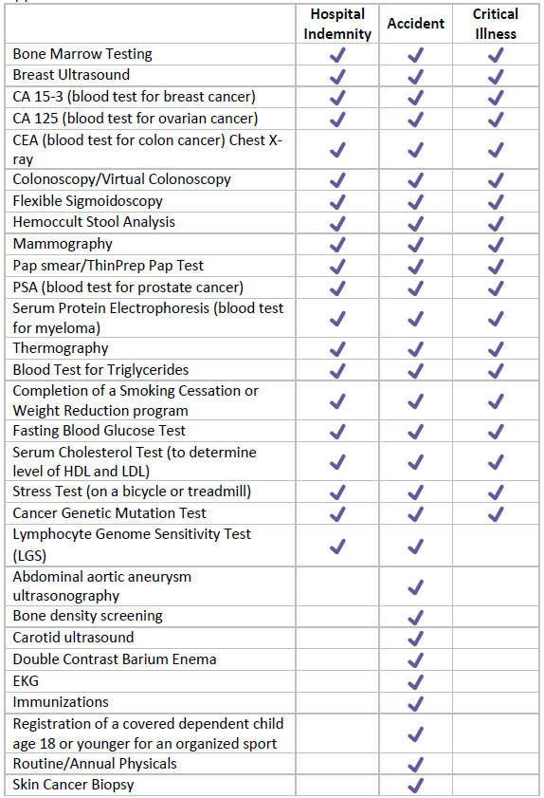

Submitting your wellness benefit claim is easy:

* Download a Wellness Benefit claim form from the   
  “Find a Form link on Guardiananytime.com

Form GG-01645

* Check off the applicable benefit(s) and complete the claim form
* Follow the directions on the claim form to submit the form for processing by Guardian.

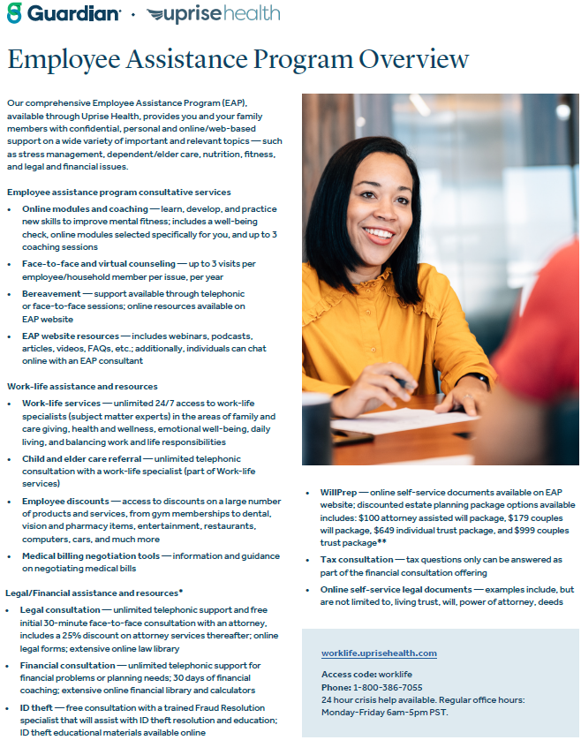

Additional miscellaneous services



GYM MEMBERSHIP REIMBURSEMENT

To promote and support the health and wellbeing of all employees the Company shall pay, on an annual basis, $1.00 for each visit to a gym of his/her choice. This benefit covers employees and adult dependents who are covered under the employee medical insurance plan.

Proof of visits from a gym or documented activity via an app or devise such as a smartwatch or fitness tracker must be submitted along with the Gym Reimbursement form in the Online Employee portal no later than January 31st for the previous year.



ONE PASS SELECT – Rediscover your passion for health

One Pass Select can help you reach your fitness goals while finding new passions along the way. Find a

routine that’s right for you whether you work out at home or at the gym. Choose a membership tier that fits your lifestyle and provides everything you need for whole body health in one easy, affordable plan. You and your eligible family members or friends can get started with One Pass Select today.

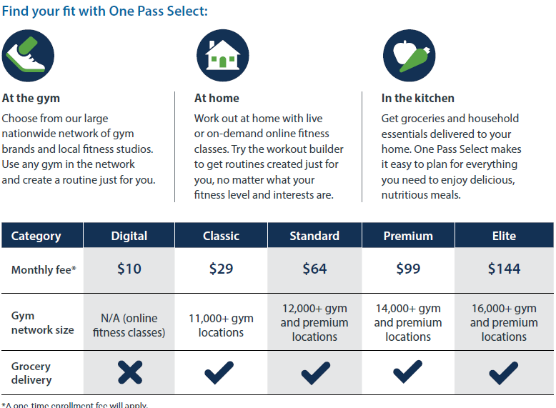



401(k)

401(k) Profit Sharing Program

Employees are eligible to participate in the 401(k) programs on the first of the month, following ninety calendar days of employment. Employees should be aware that Internal Revenue Service (IRS) limits on annual deferrals apply and that contributions to this plan, when combined with other plans in which the employee may participate, may not exceed 100% of those IRS limits.

DO YOU WANT TO MAINTAIN LIMITS HERE?

Auto-enrollment Provision

On the first of the month following ninety calendar days of employment, employees will be auto enrolled into the 401(k) plan at a rate of 2% of his/her annual earnings. The money will be invested in the plans default account. Any employee not wishing to participate in the 401(k) plan must submit a waiver form to the Human Resources department prior to the enrollment date, or by the first of any month thereafter. Failure to give notification will result in auto-enrollment.

Account Access

Employees have access to his/her 401(k) account information, Summary Plan Description, benefit statements, personal data, beneficiary designation, and loan information through the plan administrator’s secure website. Contact the plan administrator or Human Resources with questions regarding access to the website or employee rights and obligations about the 401(k) plan.

Account Changes

Employees may increase, decrease, or eliminate employee contributions to the plan by filling out a 401(k) Election Change Form. Employees elections take effect the first day of the month following the signature date.

Employer Matching Program

A contribution of an additional 25% of the employee deferral, on the first 6% of his/her contribution, may be made to the employees 401(k) account by the Company. Only those persons who participate in 401(k) programs, have worked at least 1,000 hours in a calendar year, and qualify as an employee at the end of the plan year, may receive matching funds. The decision to contribute to the employees’ 401(k) plans is at the discretion of the Company and will be made at the end of each plan year.

TIME AWAY

Holidays

Holidays are paid at eight hours of pay at the employee’s regular hourly rate. Employees are eligible for paid holidays following thirty calendar days of employment.

Holiday Schedule

* New Year’s Day
* Independence Day
* Memorial Day
* Labor Day
* Thanksgiving Day
* Day after Thanksgiving
* Christmas Eve Day
* Christmas Day

An employee must work his/her last scheduled shift before and after the holiday to be eligible for pay. Only pre-approved PTO counts as time worked for holiday eligibility.

Employee call outs, or any other leave type, for a scheduled shift before, on, or after a holiday will result in forfeiture of holiday pay.

Floating Holiday

If requested, employees to work on a holiday will be granted a floating holiday. All floating holidays must be scheduled using the time off request process by the end of the pay period in which they occur. If the floating holiday is not scheduled, the holiday pay will be paid in the period in which its occurred. No floating holiday time will be carried over from year to year. If employees are subject to time off blackout periods, floating holidays can be scheduled up to 60 days after the actual holiday.

An employee on a short-term, scheduled layoff the week of a holiday, has the right to receive holiday pay during the layoff week, provided all company requirements for the holiday pay are met. The employee must log the holiday pay on either the pay sheet or in the timeclock software to receive it. Failure to indicate such will result in no holiday pay for the pay period.

Paid Time Off (PTO)

**Exempt (Salary) Employees**

PTO offered to salaried employees is noted in the original offer of employment letter, is available to use as of the date of hire and allocated on a calendar year basis.

**PTO Carryover & Payout**

PTO Carryover and payout is determined by employment classification.

PTO offered to salaried employees is on a use it or lose it basis. No payout of unused PTO shall be awarded either at year end, or as a part of an employee’s separation from the Company.

*The information in this Enrollment Guide is presented for illustrative purposes and is based on information provided by the employer. The text contained in this guide was taken from various summary plan descriptions and benefit information. While every effort was taken to accurately report your benefits, discrepancies or errors are always possible. In case of discrepancy between the guide and actual plan documents, the actual plan documents will prevail. All information is confidential, pursuant to the Health Insurance Portability and Accountability Act of 1996. If you have any questions about the guide, please contact HR.*

|  |  |  |
| --- | --- | --- |
| Contact Information | | |
| **Provider** | **Coverage/Service** | **Contact Information** |
| FLASH Family of Companies | Human Resources | HR@FlashTrucking.com 920-294-0430 |
| UMR OptumRx | Medical  Prescription Drugs | UMR.com 800-826-97811  OptumRx.com 866-673-6293 |
| Teladoc | Virtual Care | Teladochealth.com 800-835-2362 |
| Guardian | Dental  Vision  Life  Disability | Guardianlife.com 888-600-1600 |
| John Hancock | 401(k) | Myplan.JohnHancock.com 888-695-4472 |